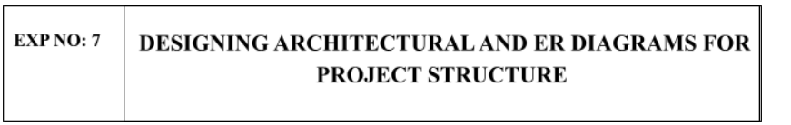

Aim:
To Design an Architectural Diagram and ER Diagram for the given Project.

7A. Architectural Diagram
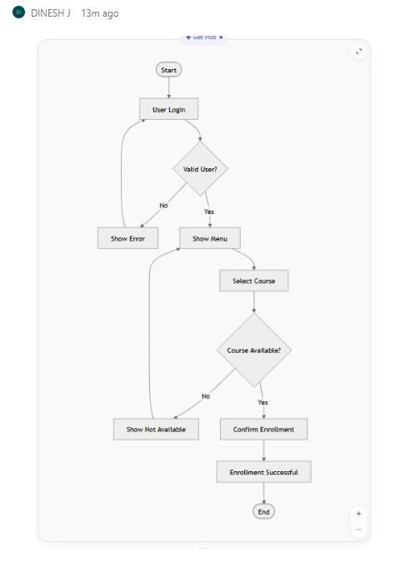

ER DIAGRAM
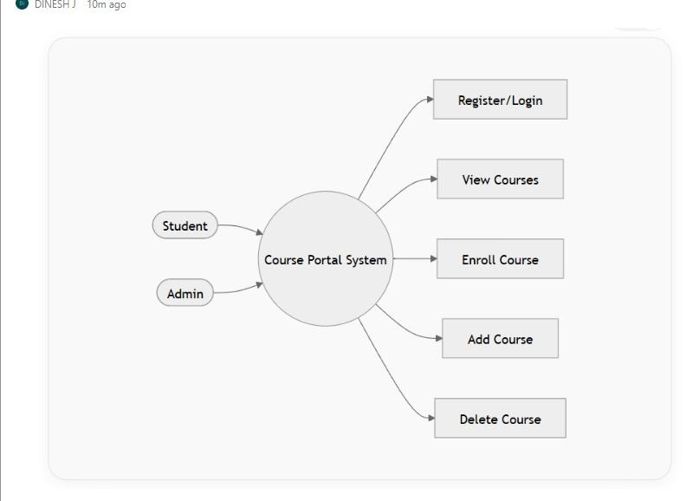

RESULT:
The Architecture Diagram and ER Diagram is designed Successfully for the Music Playlist Batch Creator

